WHISPER

HHMI Silicon Probe Extracellular Recording System

User Manual

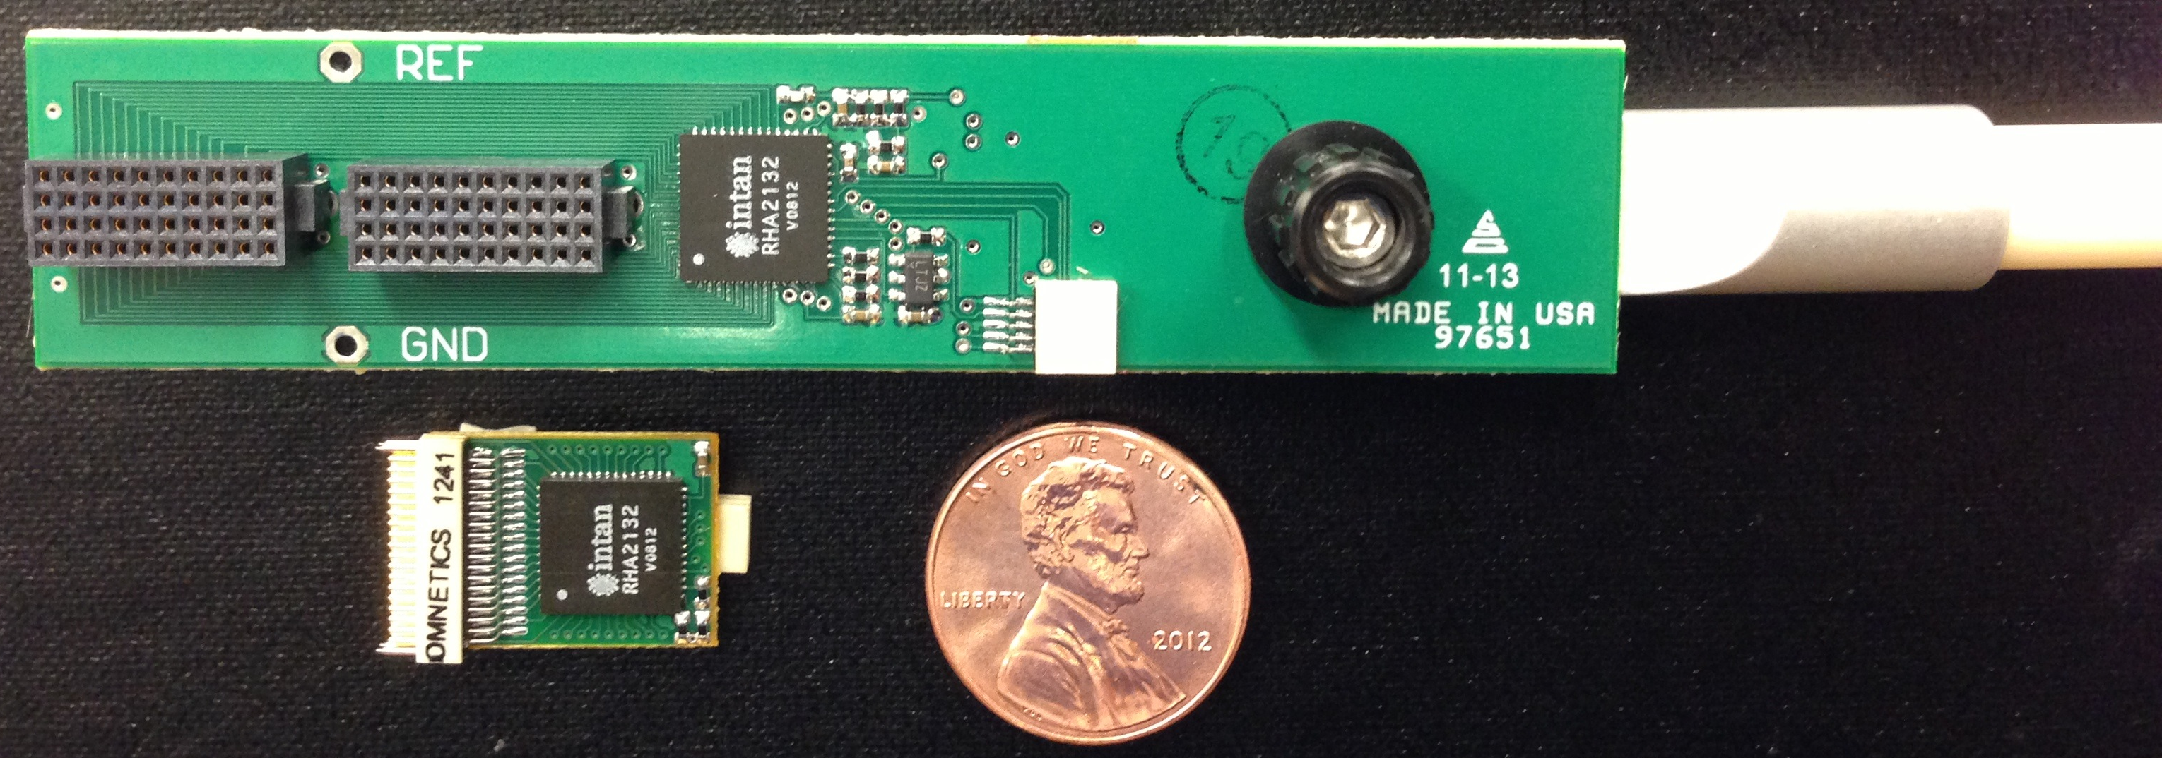

Howard Hughes Medical Institute

Janelia Farm Research Campus

Applied Physics and Instrumentation Group

19700 Helix Dr

Ashburn, VA 20147

Rev. D 10/11/17

**Objective**

The purpose of this manual is to provide step-by-step instructions to successfully perform an extracellular neural recording using the WHISPER Silicon Probe Extracellular Recording System created by the Applied Physics and Instrumentation Group of the Janelia Farm Research Campus (HHMI). Instructions for setting up and testing both hardware and software for this system are described below.

**Overview**

The goal of this work was to create a cost-effective, modular, high channel count recording system, which could be used with in-house Janelia or high site count commercial silicon probes to make both chronic and acute extracellular recordings from the brains of awake and behaving animals. In typical headstage systems, an increase in channel count leads to a proportional increase in the number of wires required to cable the headstage to the data acquisition instrumentation. A large cable will significantly hinder the performance of an animal during an experiment. In order to solve this problem, a headstage with on-board multiplexing was designed to reduce the number of cable wires. The HHMI WHISPER recording system utilizes the Intan Technologies RHA2132 (<http://www.intantech.com>) which is a fully integrated 32 channel biopotential amplifier chip, with an on-chip 32-to-1 multiplexer. This chip provides AC coupling, with a high pass pole at 0.1Hz, a low pass pole at 10kHz, and an overall gain of 200. Up to six of these chips can be connected to the system to obtain 192 channels of neural signal amplification. Two addition 32-to-1 multiplexers are used to record auxiliary inputs for both analog and digital trigger signals, allowing the user 256 channels of recorded data. The address of each multiplexer is controlled by a simple microcontroller, the PIC32MX250F128D from Microchip ([www.microchip.com](http://www.microchip.com)), whose clock is set by a 48MHz oscillator. This microcontroller also provides a trigger clock to a 16-bit National Instruments ([www.ni.com](http://www.ni.com)) data acquisition card, USB-6366, to control when data is sampled, at a 25000 Hz per channel rate. A block diagram of the system is show in Figure 1. SpikeGLX, an open-source data logging software platform (<https://github.com/billkarsh/SpikeGLX>), displays the data and saves it to disk.

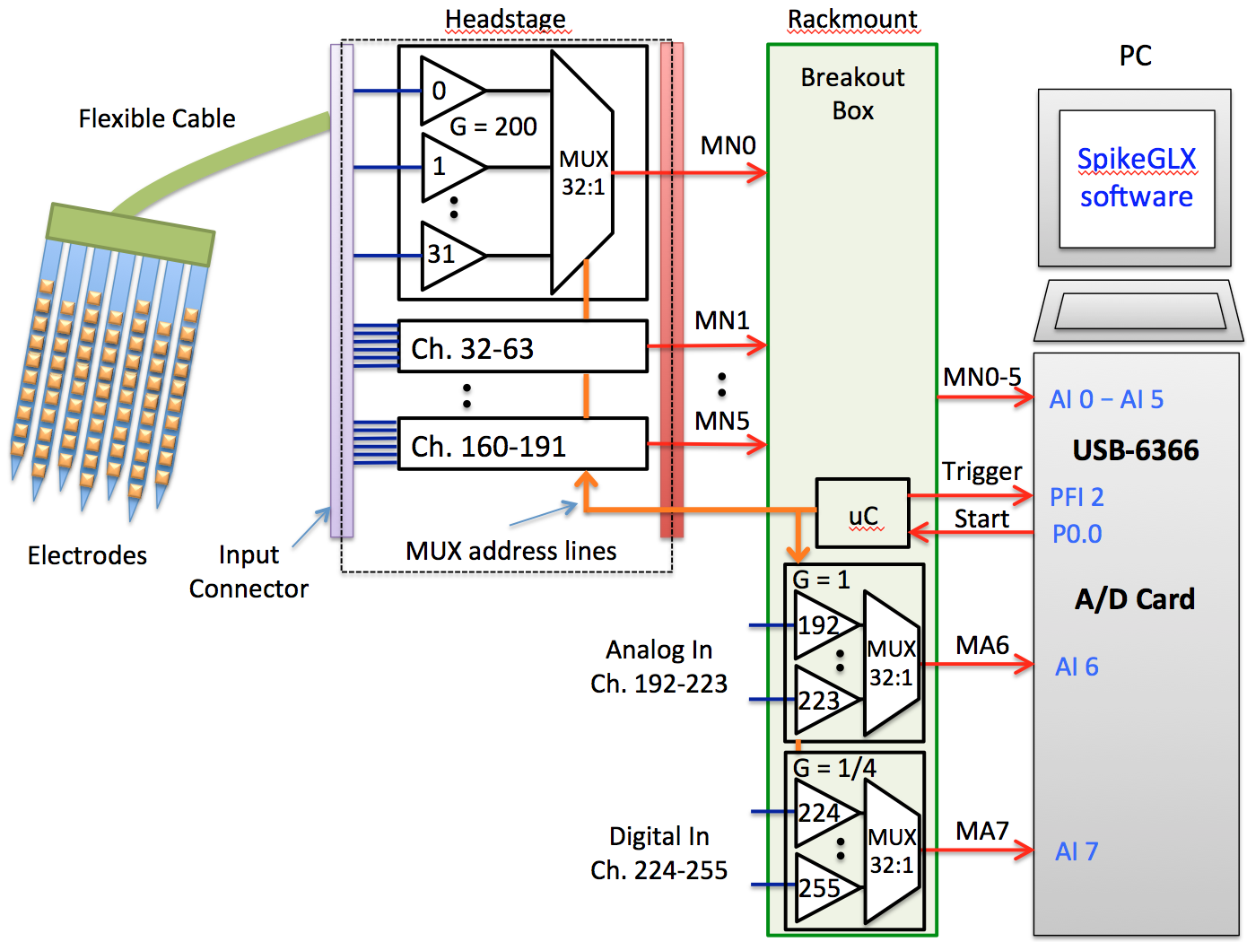

Figure 1: Block diagram of HHMI WHISPER Recording System

**Components**

The HHMI WHISPER Recording System consists of the following components:

* A lightweight, 32 Channel Chronic Headstage for freely moving recordings

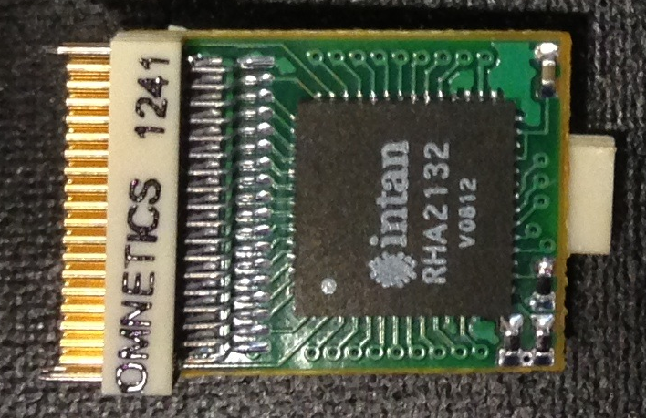

Figure 2: W32C – 32 ch chronic headstage

|  |  |
| --- | --- |
| **Specification** | **Value** |
| Total # Channels | 32 |
| Gain | 200 |
| Input Referred Noise | 2.82 µVrms (10 kHz BW) |
| -3dB high pass | 0.1 Hz |
| -3dB low pass | 10kHz |
| Power Supply | 3.3V |
| Maximum input signal | +/- 5 mV |
| Headstage Dimensions | 13.2 mm x 20.8 mm (0.52” x 0.82”) |
| Weight | 900 mg |
| Input Connector | NSD-36-AA-GS |
| Output Connector | NPD-08-AA-GS |
| Output Cable | JUM-08-NPD-NSD-WD-72.0-C-GS |

Table 1: Specifications of W32C – 32 ch chronic headstage

* A 64 channel Acute Headstage, which is mountable to a stereotactic rod for head fixed experiments.

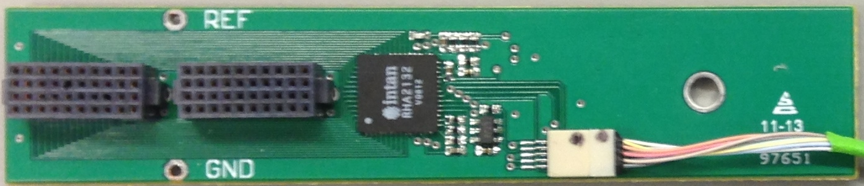

Figure 3: W64A – 64 ch acute headstage

|  |  |
| --- | --- |
| **Specification** | **Value** |
| Total # Channels | 64 |
| Gain | 200 |
| Input Referred Noise | 2.82 µVrms (10 kHz BW) |
| -3dB high pass | 0.1 Hz |
| -3dB low pass | 10kHz |
| Power Supply | 3.3V |
| Maximum input signal | +/- 5 mV |
| Headstage Dimensions | 18.3 mm x 86.6 mm (0.72” x 3.41”) |
| Weight | 8.19 g |
| Input Connector | FOLC-110-L4-S-Q (x2) |
| Output Connector | NPD-10-AA-GS |
| Output Cable | JUM-10-NPD-NSD-WD-72.0-C-GS |

Table 2: Specifications of W64A – 64 ch acute headstage

* A rack-mountable WHISPER Recording System Breakout Box, which houses a printed circuit board (PCB) that contains all necessary circuitry for interfacing the headstages to the National Instruments DAQ card, including a microcontroller which controls multiplexing and data acquisition, low-noise voltage regulators for power distribution, and inputs for both headstages; as well as for 32 analog and 32 digital aux signals (Figure 4).

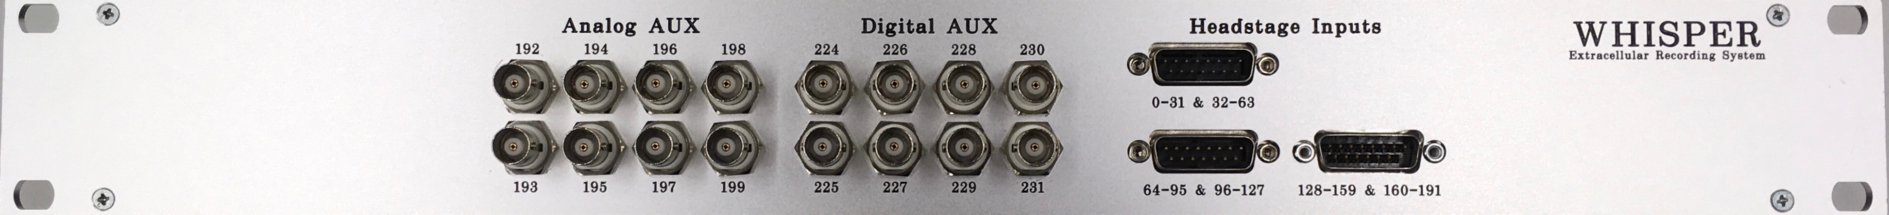

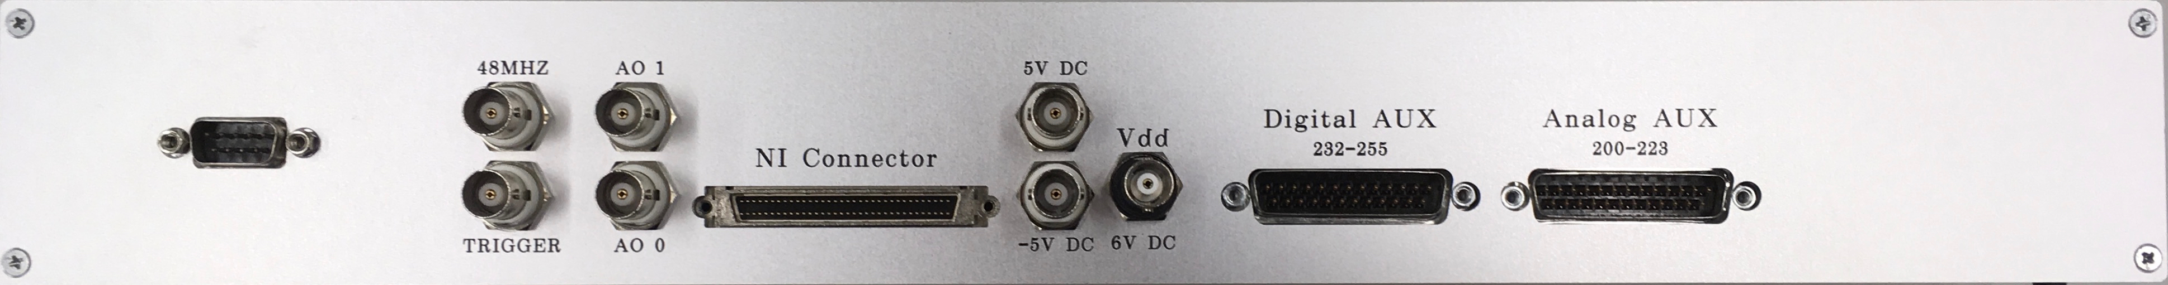

Figure 4: WHISPER Breakout Box (front & back)

**Data Acquisition Hardware**

A multifunction data acquisition card from National Instruments, the USB-6366, is required. Be careful to order the mass terminal connectivity version, part # 782264-01, to provide the proper cable interface to the WHISPER Breakout Box. An input cable and power cord must also be purchased from NI. See Table 3 for further details.

|  |  |  |
| --- | --- | --- |
| **Component** | **Value** | **Part #** |
| DAQ Card | NI USB-6366 – Mass Termination | 782264-01 |
| Input Cable | SHC68-68-EPM Shielded Cable (0.5m) | 192061-0R5 |
| Power Cable | Power Cord, A.C., U.S., 120 VAC (2.3m) | 763000-01 |

Table 3: DAQ Hardware Specs

**Software and Computer Requirements**

The required software is ***SpikeGLX***, an open-source high-speed data logging application optimized for acquiring synchronous high channel data. The project is located at <https://github.com/billkarsh/SpikeGLX>, which provides more information including official compiled software releases, a user manual, and list of basic computer requirements (See Table 4).

|  |  |
| --- | --- |
| **System Requirement** | **Value** |
| Operating System | Windows XP SP3, 7, 8.1, 10 |
| # of Cores | Minimum 4 cores |
| Processor Speed | Minimum 2.5 GHz |
| RAM | Minimum 4 GB |
| Hard Drive | Dedicated 2nd hard drive for data streaming |
| National Instruments Drivers | NI-DAQmx 9 or later (recommend latest version) |

Table 4: Minimum Computer Specs

**Additional Hardware**

In addition to a computer, the user will also need a power supply to provide 6V DC, +5V DC, and -5V DC to the system; the Keysight Technologies E3630A is recommended.

**Basic Hardware Setup**

1. Download and install the latest version of NI DAQmx from National Instruments
2. Plug in power cable to USB-6366 and USB cable into the computer.
3. Turn on USB-6366, computer should recognize. To confirm proper installation navigate to, Start Menu > All Programs >> National Instruments > NI MAX. NI USB-6366 should active (Figure 5).

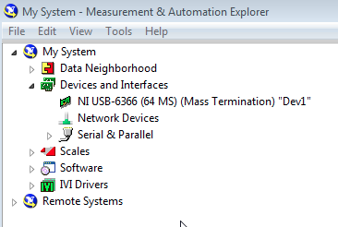

Figure 5: USB-6366 should be visible in NI MAX

1. Click on the USB-6366 device and then click the Self-Test button. Make sure the device passes the test (Figures 6 & 7).

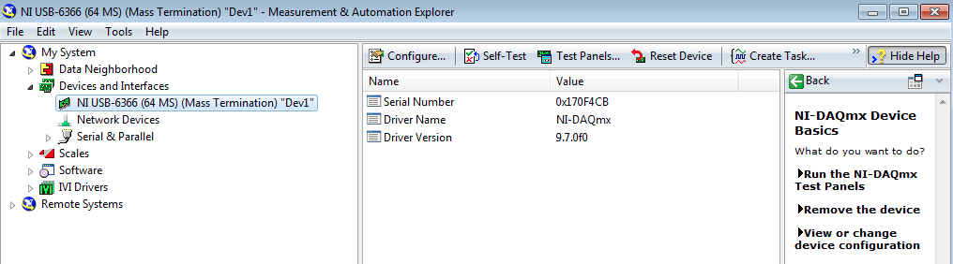

Figure 6: Self-test window

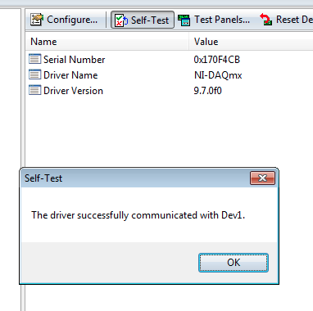

Figure 7: Successful Self-test

1. An external 6V DC power supply must be connected to the Vdd BNC plug on the backside of the WHISPER Breakout Box (Figure 8). Note the current draw of 0.05-0.06A, which is the nominal value when no headstages are attached.

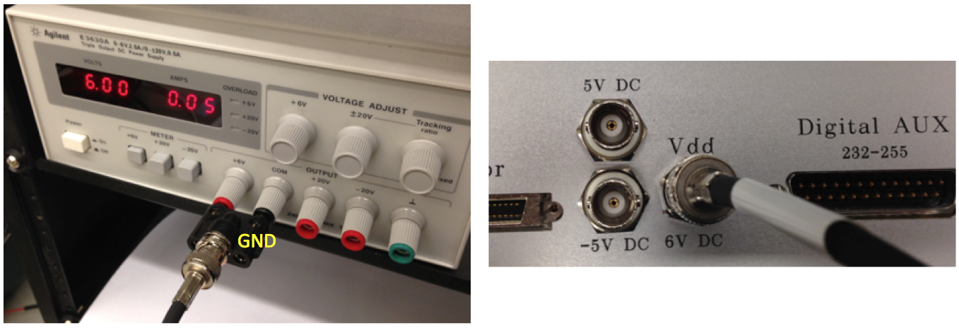

Figure 8: Agilent E3630A power supply plugged into Vdd of WHISPER Box.

**Note the orientation of the GND tab of the Banana Plug to BNC female connector. Reversing the polarity of the power supply might damage the hardware.**

1. An external +5V DC power supply must be connected to the 5V DC BNC plug on the backside of the WHISPER Breakout Box (Figure 9). Push the +20V meter button. Note the current draw of 0.01A, which is the nominal value.

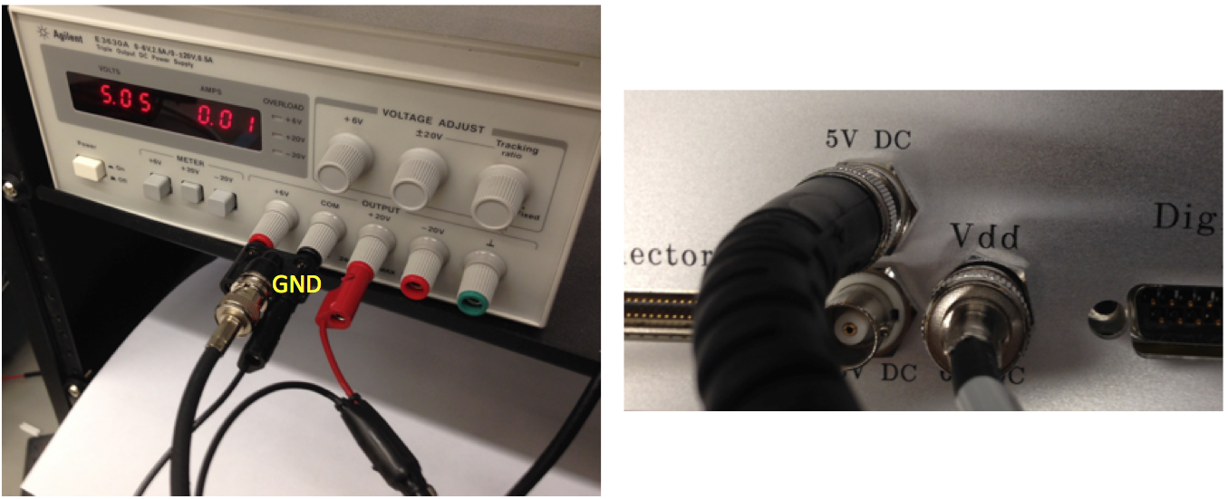

Figure 9: Agilent E3630A power supply plugged into 5V DC of WHISPER Box.

**Note the orientation of the GND tab of the BNC to banana plug cable. Reversing the polarity of the power supply might damage the hardware.**

1. An external -5V DC power supply must be connected to the -5V DC BNC plug on the backside of the WHISPER Breakout Box (Figure 10). Push the -20V meter button. Note the current draw of 0.04A, which is the nominal value.

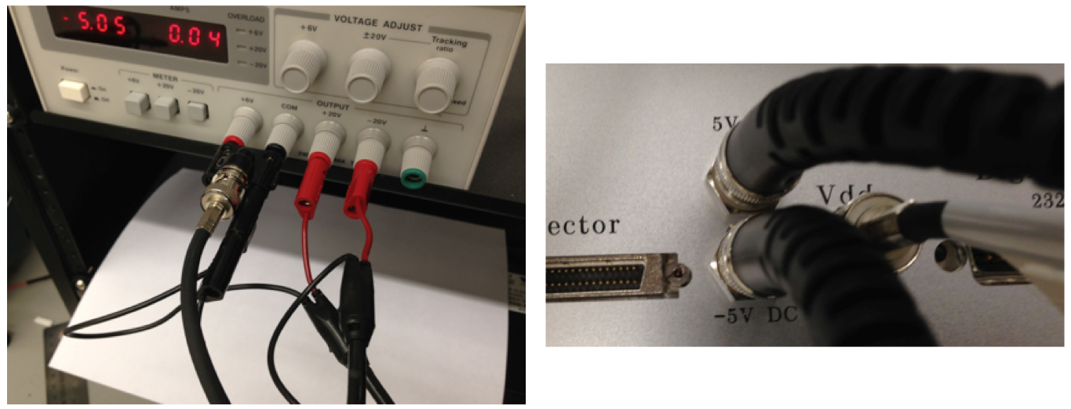

Figure 10: Agilent E3630A power supply plugged into -5V DC of WHISPER Box.

**Note the orientation of the GND tab of the BNC to banana plug cable. Reversing the polarity of the power supply might damage the hardware.**

1. Push the +20V meter button and note the current draw is 0.04Am, which is the nominal value when both 5V and -5V DC are both powered (Figure 11).

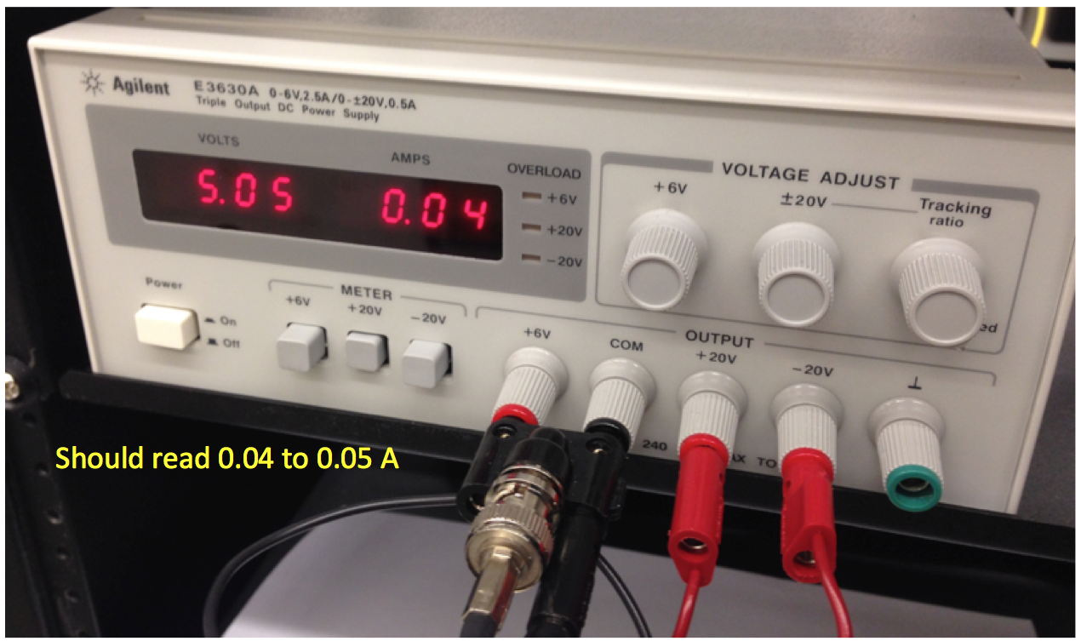

Figure 11: Agilent E3630A power supply when both powered with 5V & -5V DC

1. Connect the NI cable to both the USB-6366 card and to the WHISPER Breakout Box (Figure 12). Tighten the jackscrews on either side of the cable.

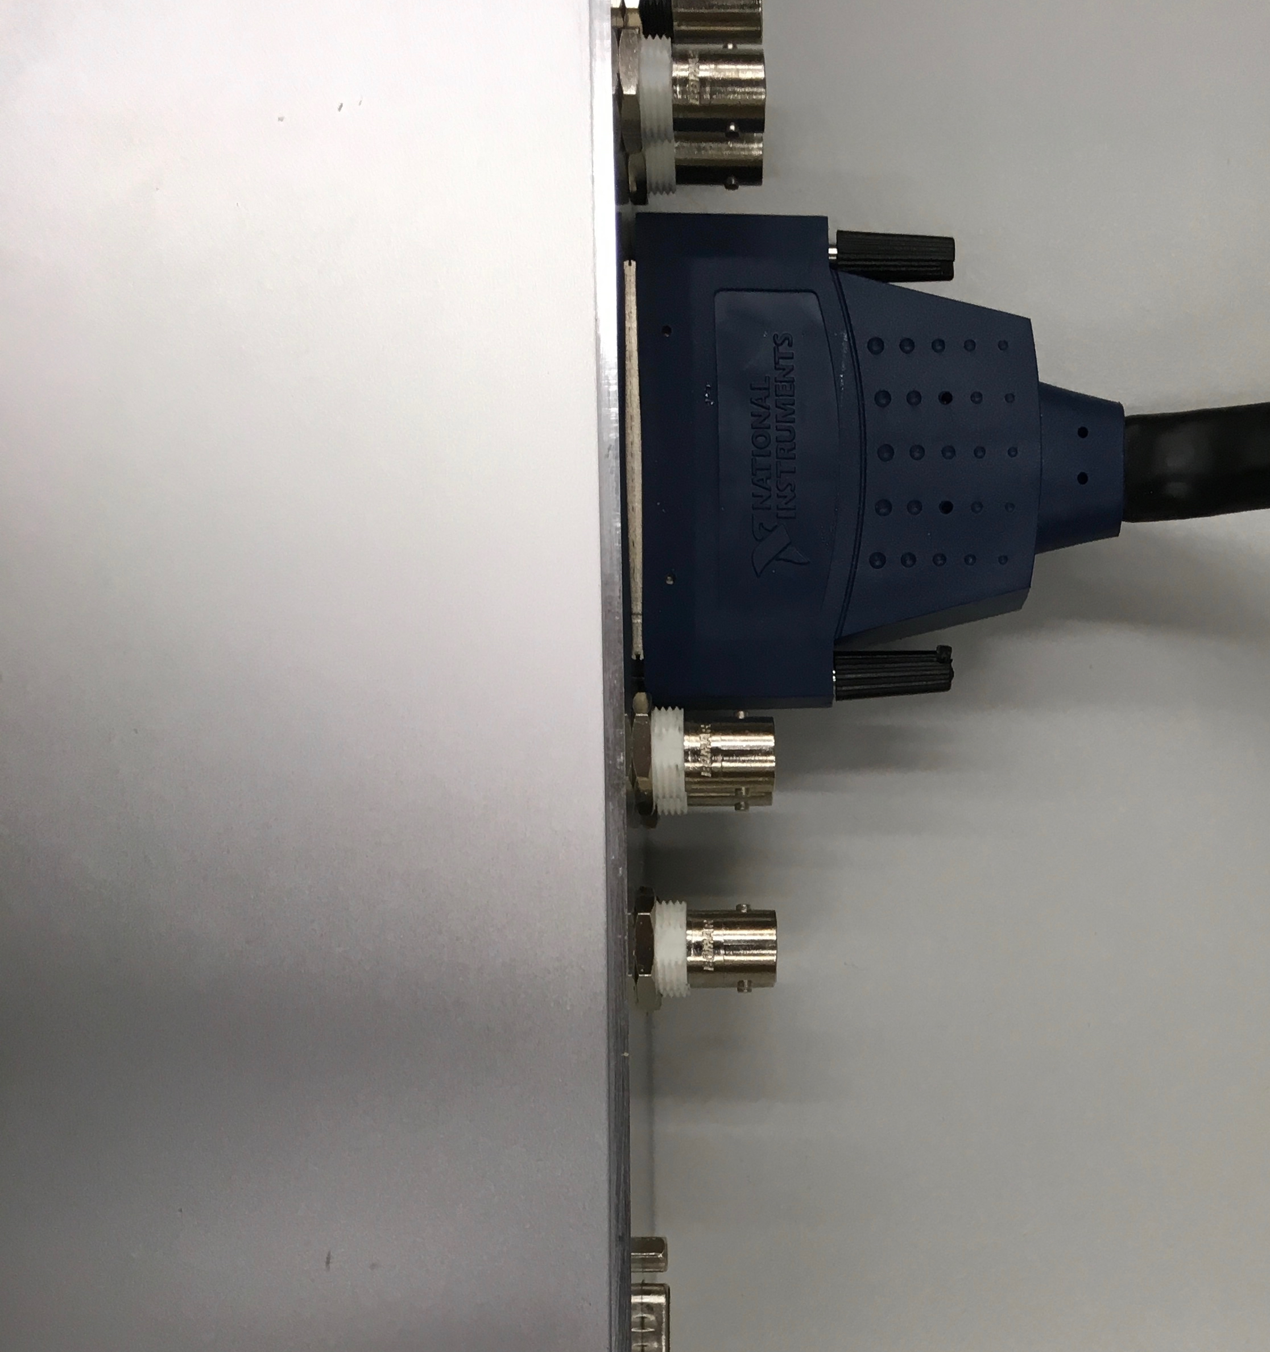

Figure 12: NI cable plugged into WHISPER Box

1. The desired Interface Board (Omnetics to DSUB) can be plugged into the inputs of the WHISPER Breakout Box (See Modularity Section for more details). Corresponding Omnetics cables should also be plugged into the headstages. Please note there is a small dot on each gender of the connectors, please make sure these are aligned to each other (Figure 13). Failure to do so could damage the amplifiers.

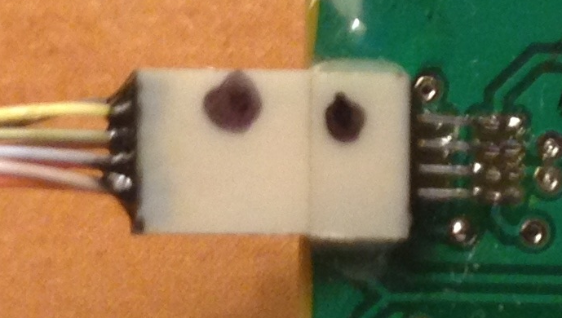

Figure 13: Alignment of Omnetics connectors. Dot aligns to dot

**Basic Software Setup**

1. Download the latest release of SpikeGLX (<http://billkarsh.github.io/SpikeGLX/>)
2. Unzip downloaded file and simply copy the SpikeGLX release folder to your C drive.
3. Double click on SpikeGLX.exe to start software.

**Modularity**

Both SpikeGLX and the WHISPER Recording System provide a flexible platform to allow for a wide range of diverse and intricate experiments to be carried out. The inputs to the WHISPER Breakout Box are meant to be interchangeable between chronic and acute headstages. There are three male 25-DSUB connectors on the front of the Whisper Breakout Box, each with the capacity of hooking up either a single W64A or a pair of W32C headstages by simply using the proper Interface Board (Omnetics to DSUB) (Figures 14 & 15). A few example configurations are show below (Figures 16-18).

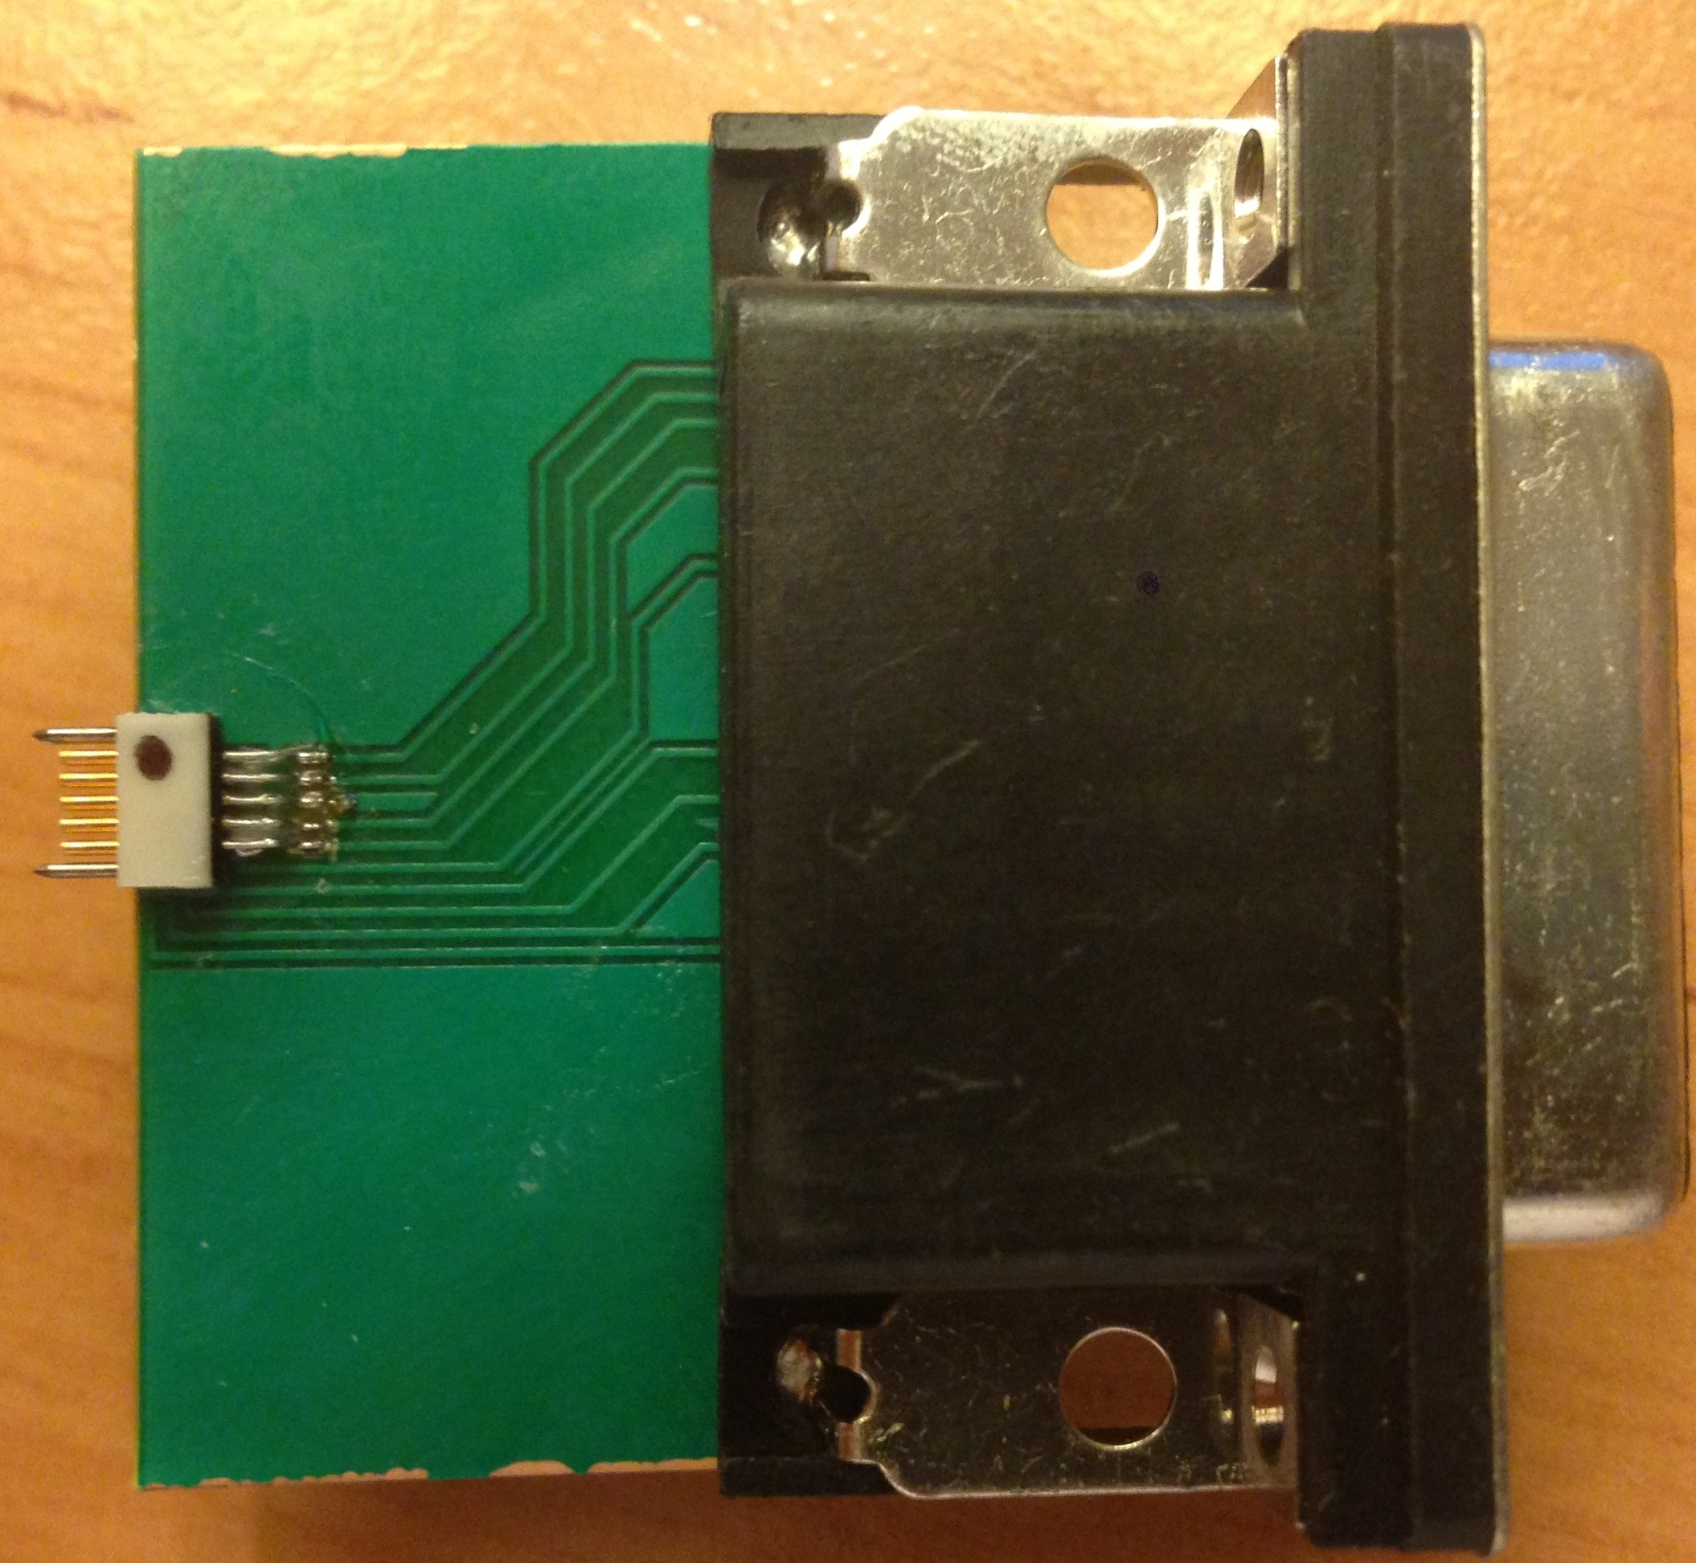

Figure 14: Interface Board (Omnetics to DSUB) for x1 W64A headstage

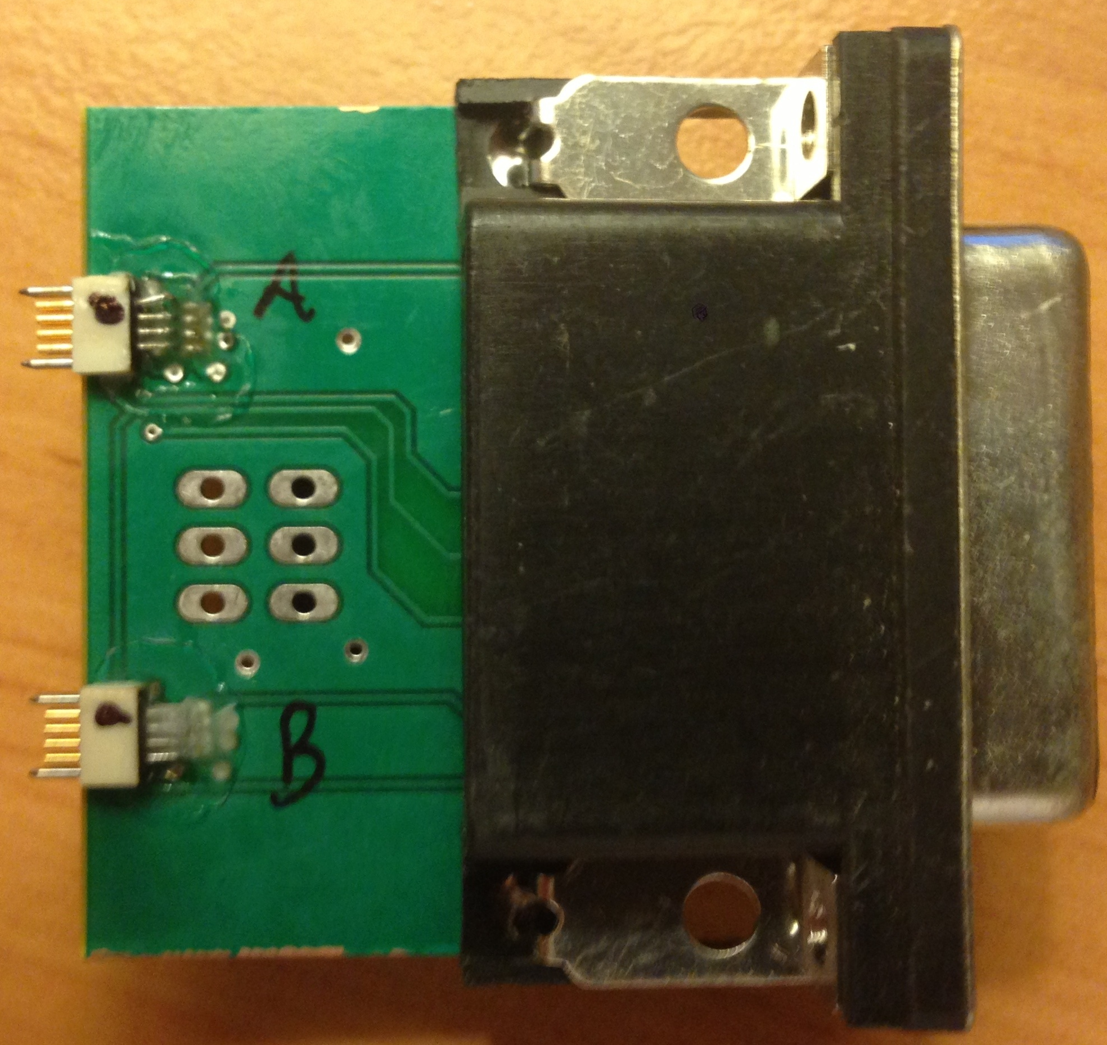

Figure 15: Interface Board (Omnetics to DSUB) for x2 W32C headstages

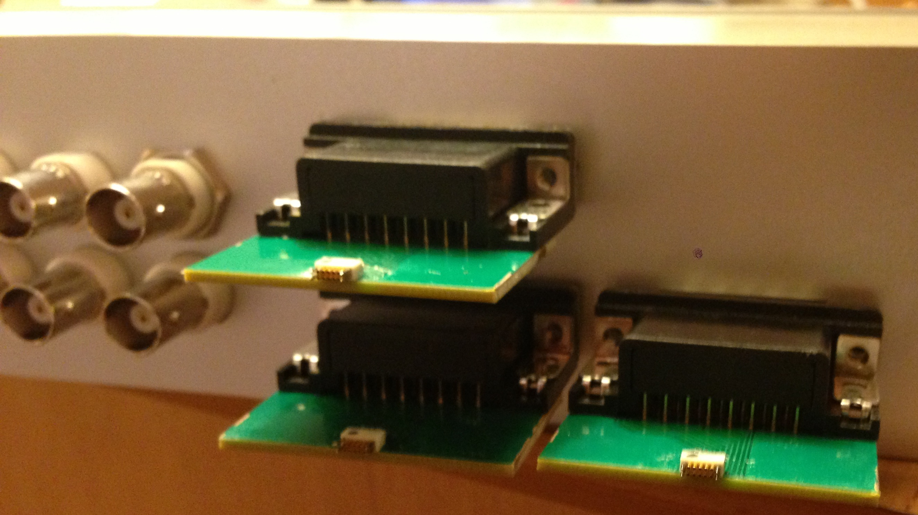

Figure 16: x3 W64A headstages

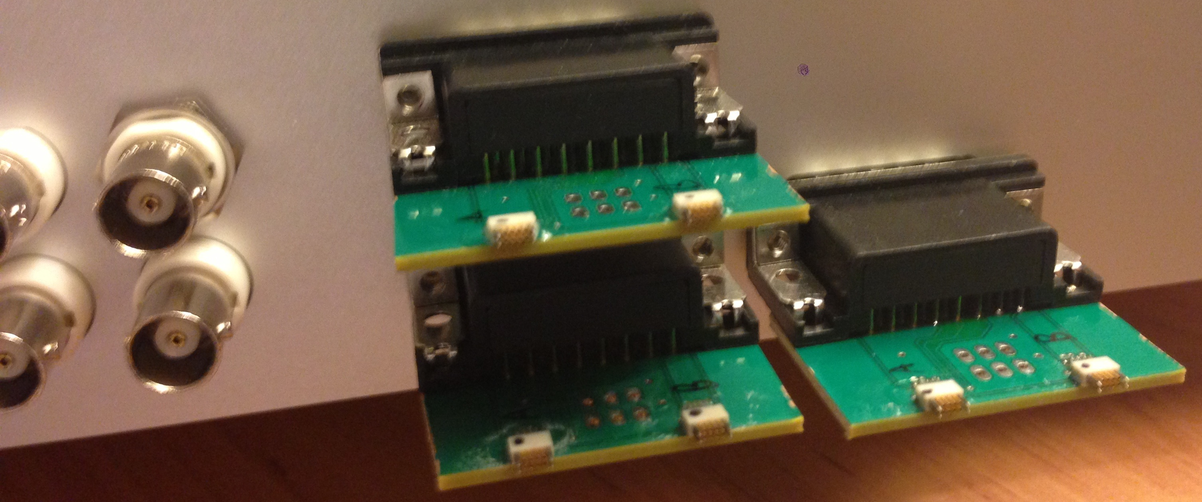

Figure 17: x6 W32C headstages

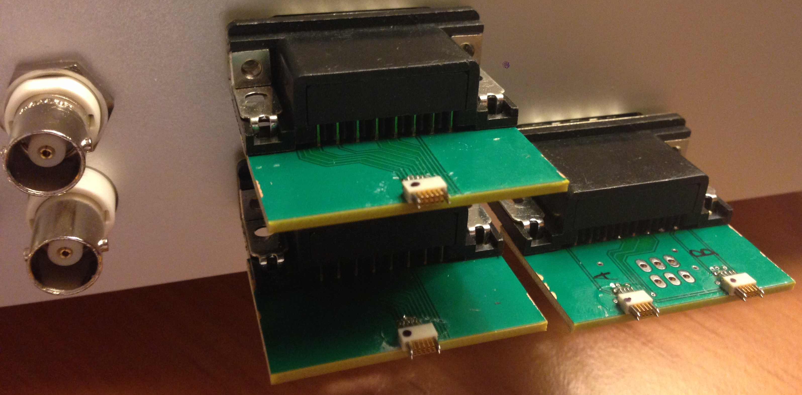

Figure 18: x2 W64A, x2 W32C headstages

An understanding of the physical connections between the WHISPER Breakout Box and the NI DAQ card (USB-6366) is required to properly setup channels in SpikeGLX. There are 8 analog inputs (AI0 to AI7) to the USB-6366, with AI0 to AI5 dedicated to headstages (MN - multiplexed neural channels), AI6 and AI7 dedicated auxiliary channels (MA – multiplexed analog channels) (Figure 19). Note: each DSUB connector has a NI input marked to the left and to the right, which corresponds exactly to how the Interface Board (Omnetics to DSUB) for x2 W32C would connect to each W32C headstage. An Interface Board (Omnetics to DSUB) for x1 W64A uses both NI inputs.

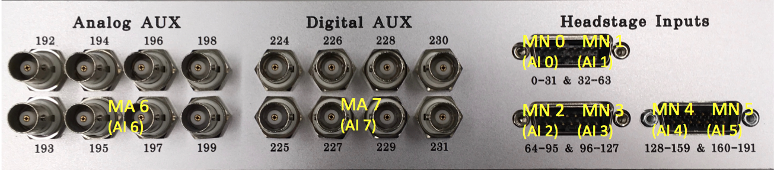

Figure 19: NI Card & SpikeGLX NI Channel Type connections on WHISPER Breakout Box. MA6 (AI 6) is shared across all Analog Aux, MA 7 (AI 7) is shared across all Digital AUX.

All channels are first multiplexed onto the corresponding analog input of the NI card and then demultiplexed in software. All multiplexers contain 32 channels per multiplexer. Since the USB-6366 acquired each of its channels simultaneously; both the neural data and external triggers will be recorded with microsecond resolution. See Table 5 for more details about channel type, max input voltage, and gain. The channel # defined in this table assumes all NI channels are being defined as MN & MA in SpikeGLX.

|  |  |  |  |  |
| --- | --- | --- | --- | --- |
| **NI Card Input** | **SpikeGLX - NI Channel Type** | **Max Input Voltage** | **Gain** | **Channel #** |
| AI 0 | MN 0 | +/- 5 mV (Intan RHA2132) | 200 | 0-31 |
| AI 1 | MN 1 | +/- 5 mV (Intan RHA2132) | 200 | 32-63 |
| AI 2 | MN 2 | +/- 5 mV (Intan RHA2132) | 200 | 64-95 |
| AI 3 | MN 3 | +/- 5 mV (Intan RHA2132) | 200 | 96-127 |
| AI 4 | MN 4 | +/- 5 mV (Intan RHA2132) | 200 | 128-159 |
| AI 5 | MN 5 | +/- 5 mV (Intan RHA2132) | 200 | 160-191 |
| AI 6 | MA 6 | +/- 2.5V (WHISPER Analog AUX) | 1 | 192-223 |
| AI 7 | MA 7 | +/- 10V (WHISPER Digital AUX) | 1/4 | 224-255 |

Table 5: Details of WHISPER System Channels settable in SpikeGLX

**Headstage Mapping**

Since different combinations of headstages can be used with this system, the mapping from headstage input to channel recorded in SpikeGLX must be carefully accounted for. The mapping for the simplest configuration of a W32C – 32 ch chronic headstage plugged into the AI 0 (MN 0) input (Figure 20) and for a W64A – 64 ch acute headstage plugged into the AI 0 (MN 0) and AI 1 (MN 1) inputs (Figure 21). Headstage channels scale accordingly to how they are plugged into the WHISPER Breakout Box. For example if a W32C is plugged into AI 1 (MN 1), channel 0:31 becomes 32:63, or if a W64A is plugged into AI 2 (MN 2) and AI3 (MN 3), channel 0:63 becomes 64:127. ***Note: each headstage has its own independent reference, which must be accounted for when using multiple headstages.***

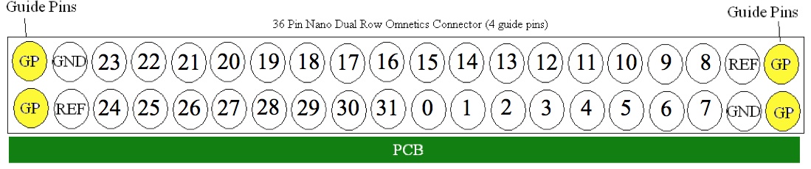

Figure 20: Mapping of a W32C - 32 ch chronic headstage (Plugged into MN0)

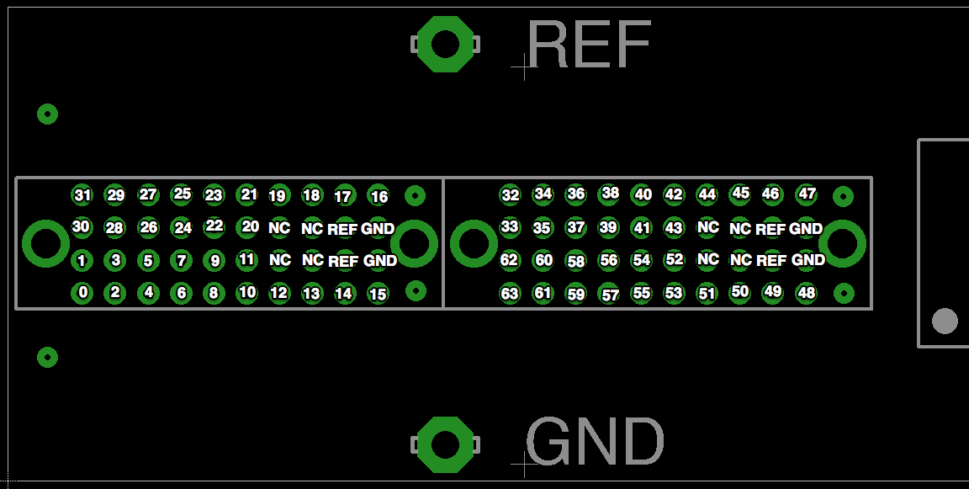

Figure 21: Mapping of a W64A – 64 ch acute headstage (Plugged into MN0 & MN1)

**Auxiliary Channel Mapping**

There are 32 analog auxiliary, and 32 digital auxiliary channels available, with BNC connectors available for the first 8 channels of each. The corresponding channel number is labeled on the front of the Whisper Breakout Box. The other 24 channels of each are located on the back. A pinout for each is found in Figures 22 and 23.

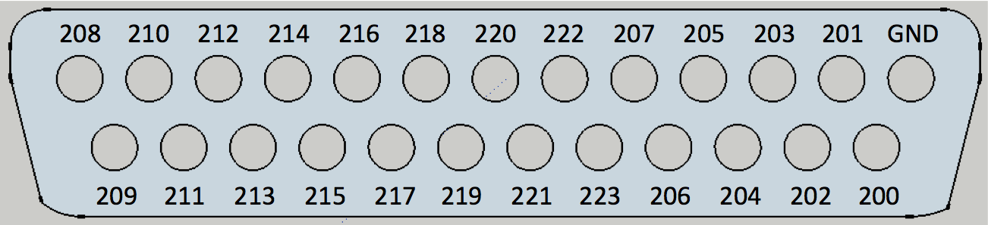

Figure 22: Pinout Analog AUX channels (200 - 223) – connector – male DSUB25

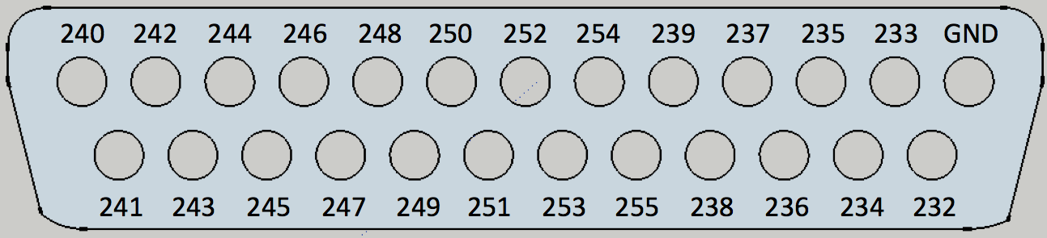

Figure 23: Pinout Digital AUX channels (232 - 255) – connector – male DSUB25

**Running an Experiment**

To run a new experiment, open the SpikeGLX application and click ***File > New Acquisition***. This will display the Configure Acquisition window, which allows the user to setup all necessary parameters for proper data acquisition. It should be noted that SpikeGLX is capable of collecting data from IMEC probes (Neuropixels) as well as from WHISPER (NI-DAQ) simultaneously. For more information please see the SpikeGLX Help document located within SpikeGLX. The following tutorial will highlight running SpikeGLX with only a WHISPER recording system.

**NI Setup**

1. Select checkbox ***Enable NI-DAQ***
2. Click ***Detect*** button. A list of all of the NI hardware hooked to your computer will be listed.
3. Click on the ***NI Setup***tab. The default setup is shown in Figure 24.

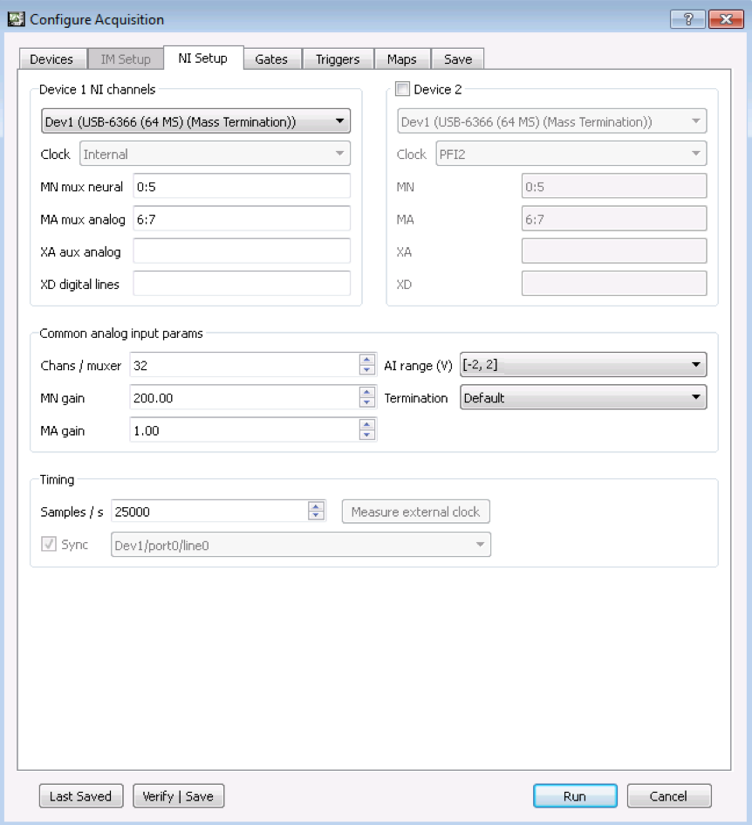

Figure 24: NI Setup Tab with the default setup for WHISPER

|  |  |  |
| --- | --- | --- |
| **Parameter** | **Description** | **Default Value** |
| MN mux neural | Multiplexed neural channels from WHISPER amplifiers (W32C & W64A) | 0:5 |
| MA mux analog | Analog & digital auxiliary channels from WHISPER Box | 6:7 |
| Chans / muxer | # of channels of the multiplexer | 32 |
| MN gain | Gain of multiplexed channels. Set in hardware | 200 |
| MA gain | Gain of MA mux analog channels | 1 |
| AI Range Min-Max | Analog voltage range of DAQ card | [-2, 2] |
| Termination | NI Card GND scheme setting | Default |

Table 6: Default parameters for NI Setup for WHISPER

1. Click ***Measure external clock***. This will check the per channel sampling clock set by the WHISPER system hardware. Default value will be 25000 Samples / s. You only need to check this the first time you are setting up the system.

**Gates / Triggers**

Experiments in SpikeGLX are defined by the ***run / gate / trigger*** scheme. The **run folder** is where all data files are stored. ***Gates*** and ***triggers*** work together to define when data is written to disk. ***Triggers*** can only operate when the ***gate*** is enabled (high). Each time the ***gate*** is enabled, the defined ***trigger mode*** is reevaluated. The different modes of gates (Table 7) and triggers (Table 8) are defined below.

A few notable features: both gates and triggers can be controlled by TCP/IP commands, to allow for experiment control through another program such as Matlab. There is also an optional ***gate manual override*** setting, which allows the user to start SpikeGLX without saving files or to quickly restart experiments with a new run name or updated gate/trigger index.

|  |  |
| --- | --- |
| **Mode** | **Description** |
| Immediate Start | Gate is immediately set high at the start of the run |
| Remote controlled start and stop | Gate is controlled by TCP/IP (ie. Matlab) |

Table 7: Gate modes

|  |  |
| --- | --- |
| **Mode** | **Description** |
| Immediate Start | Trigger is immediately set high at the start of the run and remains high until the end of the run |
| Timed start and stop | Trigger is set high after a defined waiting period (L0), writes for H seconds, idle for L seconds, and repeat N times |
| TTL Controlled start and stop | Trigger is set high by a user defined channel for a positive going threshold crossing. Can be latched high until the end of run, write for H seconds, or write until channel crosses below threshold. Useful for creating trial based files |
| Spike detection start and stop | Trigger is set high after a negative threshold crossing, which saves a peri-event window around the spike detected. Can be set to repeat indefinitely, with a setable refractory period. Note: threshold detection is applied after a 300Hz software filter. |
| Remote controlled start and stop | Trigger is controlled by TCP/IP (ie. Matlab) |

Table 8: Trigger modes

1. This tutorial will setup SpikeGLX to begin immediately saving data to disk. Under the ***Gates tab***, select ***Immediate start***. Leave the checkboxes empty for both Show enable/disable recording button and Disable recording at run start
2. Under the ***Triggers tab***, select ***Immediate start***.

**Save**

The parameters of the NI Setup tab define all of the channels acquired from the hardware. SpikeGLX displays all of these channels in the Graphs window. The user is able to select which of these channels they would like to save to disk in the Save tab.

1. Under ***Channels to save: NI***, enter the desired channel from the range of 0 to N (where N is the total channel number). To save all channels use ***all*** or *\**. For example, 0:31, 192, 224:226 – would save the first 32 channels as well as aux channels 192, 224, 225, and 226.
2. Enter the desired folder to save data under ***Run File, Run directory***.
3. Enter the desired filename under ***Run filename.*** Note: The index of the gate / trigger will be appended to the end of the chosen filename. Once the run is started these indexes will automatically be advanced without having the manually changing the filename. For example, if the filename is selected to be *testWhisper*, would create a NI binary data file labeled *testWhisper_g0_t0*, and the next trigger would increment to *testWhisper_g0_t1*. Resetting the gate would produce *testWhisper_g1_t0*.
4. Click ***Run*** to begin the experiment

**Graphs Window**

The main graphical display window of SpikeGLX is shown in Figure 25. A description of the key components of this window is provided in Table 9. It should be noted that operations (including filtering and spatial averaging) performed on the data only affect the visualization of the data in the Graphs window. The raw data, as acquired by the hardware, is stored to disk.

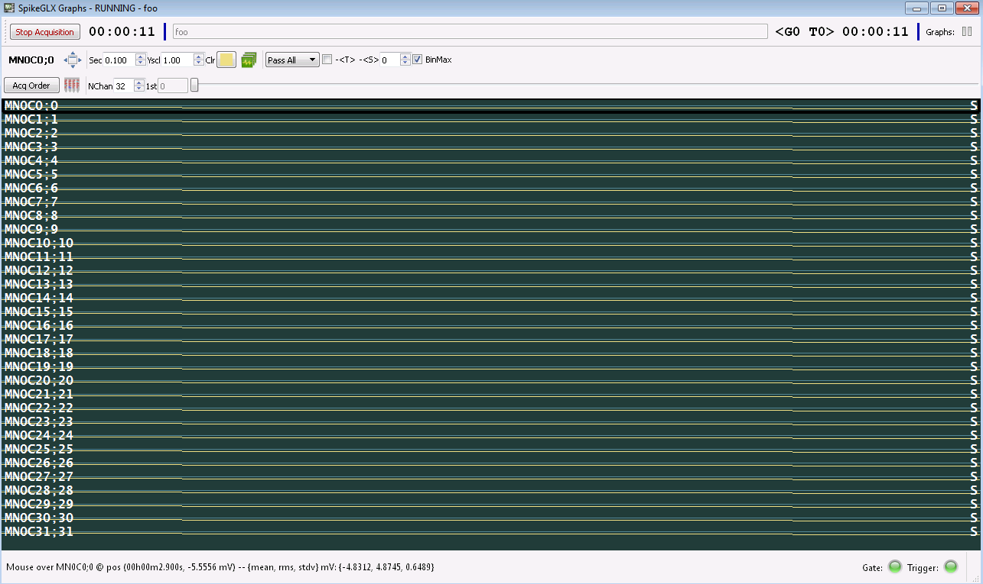

Figure 25: Graph window of SpikeGLX

|  |  |
| --- | --- |
|  | Stops the run. Same as closing graph window |
|  | Acquisition Clock – time from the start of run |
|  | Recording Clock – time from the start of the current file being saved – contains info about gate and trigger |
|  | Pause display, data still is streaming to disk |
|  | Name of the selected channel on graph |
|  | Toggle between selected channel and all channels |
| C:\Users\anikduttaroy\Desktop\work\Headstage\SpikeGL instruction manual\Spike GL graph.JPG | X axis scale – [0.001 to 30.0] second |
| C:\Users\anikduttaroy\Desktop\work\Headstage\SpikeGL instruction manual\Spike GL graph.JPG | Y axis scale [0.0 to 9999.0] |
| C:\Users\anikduttaroy\Desktop\work\Headstage\SpikeGL instruction manual\Spike GL graph.JPG | Color of graph |
| C:\Users\anikduttaroy\Desktop\work\Headstage\SpikeGL instruction manual\Spike GL graph.JPG | Apply settings for one graph to all |
|  | Software file – Pass All = No filter, 300 – INF = AP band, 0.1 – 300 = LFP band. |
|  | Time average across each channel (DC subtraction) |
|  | Spatial averaging – each time point is averaged across a defined radius and subtracted from each channel. Electrode locations are defined in shank map. 0 = no spatial average, 1 = 1 electrode, etc. |
|  | If checked, plots the most positive or negative data point within the down-sampled channel bin. Useful for visualizing spikes, but makes background noise look worse |
| / | Toggle the order channels are graphed. Acquired (standard) order or user defined by a custom channel map |
|  | Displays shank map |
|  | # of channels displayed on the Y axis |
|  | Sliding scale used to select pages of channels |
|  | On the right hand side of the channel graph – S = saved, empty = not saved |
|  | Indicator if Gate & Trigger are enabled. Green = enabled, Red = disabled |

Table 9: Components of the SpikeGLX Graph Window

**Data Files** Two files are created for every triggered recording, a metafile, .meta, and binary data file, .bin. The metafile contains all of the relevant setup information, including time of the recording, hardware setup, file size, channel map, etc. The binary file contains all of the record data. The structure of the file is as follows: each column of the file is a separate channel, starting from left to right with MN mux neural, then MA mux analog, then XA aux analog (non-mux), and finally XD digital lines. Each row is one timestep of data, defined by the per channel sampling rate (niSampRate), with the first row occurring at t = 0. The 2nd row occurs at 1/niSampRate, 3rd row occurs at 2/niSampRate, and so forth.

There is also a file viewer built into SpikeGLX. To use, select File > Open File Viewer and select a saved .bin file. The interface is almost identical to the Graph Window, with a time (x-axis) scroll bar at the bottom to advance through the data.

**Reading Data Files into Matlab**

There is a folder labeled, SpikeGLX-MATLAB-SDK located with the downloaded Release folder of SpikeGLX (<http://billkarsh.github.io/SpikeGLX/> for latest compiled release version). An .m file labeled DemoReadSGLXData.m contains functions and example code to read .bin files recording using SpikeGLX